CSA-1024 Bharath raj S 192521082

EXPERIMENT 1: JIRA KANBAN BOARD

1. Aim
To create a Kanban board in Jira with To Do, In Progress, and Done columns, add sample tasks, and simulate the movement of tasks through the workflow.

2. Software Requirements
- Software: Jira
- Platform: Web Browser
- Application: Atlassian Jira
- Project Name: Student Task Management

3. Procedure
Step 1: Open Jira
Opened the Jira application through a web browser and logged in using an Atlassian account.
Step 2: Create a Project
Created a new project named Student Task Management using the Kanban project template.
Step 3: Open the Kanban Board
Opened the newly created project and accessed the Board section. Verified the three columns: To Do, In Progress, and Done.
Step 4: Create Tasks
Created the following five sample tasks using the Create option in Jira:
- Design Student Registration Form
- Develop Login Module
- Create Student Database
- Test Application
- Prepare Project Report
Step 5: Move Tasks to In Progress
Selected a task from the To Do column and moved it to the In Progress column to represent work that had started.
Step 6: Move Tasks to Done
Moved a task from In Progress to Done to represent the completion of the task.
Step 7: Simulate the Workflow
Moved task cards across the columns to demonstrate the workflow:
To Do → In Progress → Done
Step 8: Verify the Board
Checked the final Kanban board and verified that all five tasks were displayed in their respective columns.

4. Algorithm
- Start.
- Log in to Jira.
- Create a Kanban project.
- Configure the To Do, In Progress, and Done columns.
- Add five sample tasks.
- Move tasks between the columns according to their progress.
- Verify the status of each task.
- Stop.

5. Screenshots / Output

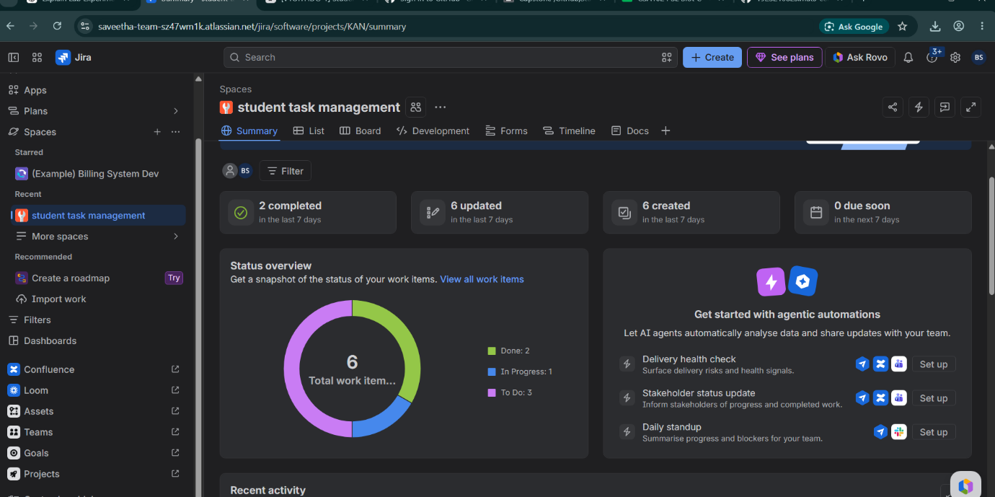

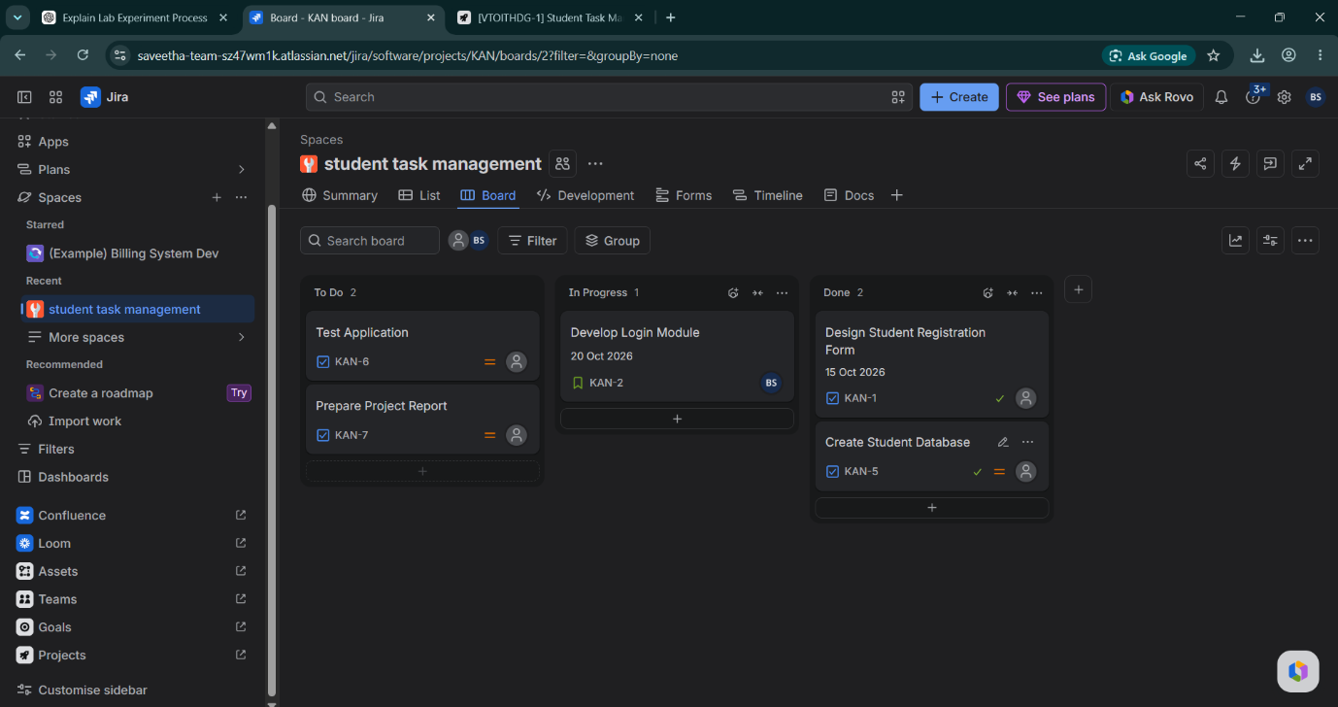

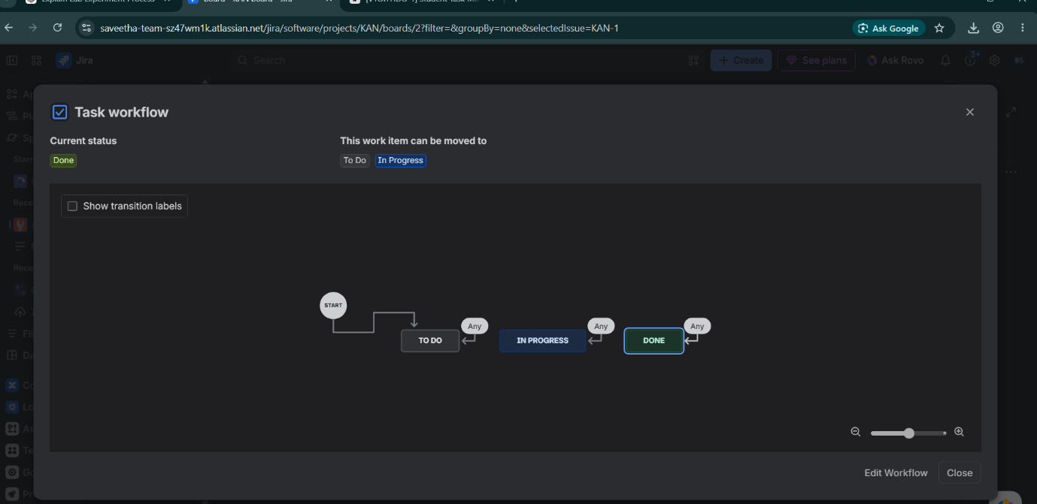

6. Observation
- To Do: Represents tasks that have not started.
- In Progress: Represents tasks currently being worked on.
- Done: Represents completed tasks.
- Moving task cards between columns represents progress in the project.
- Jira provides a visual method for tracking and monitoring tasks.

7. Result
Thus, a Kanban board was successfully created in Jira with To Do, In Progress, and Done columns. Five sample tasks were added, and the movement of tasks through the workflow was demonstrated successfully.

